Day Hiking Checklist
Below is a comprehensive list of items that should be included in your pack or on your body anytime you hike into the back country.

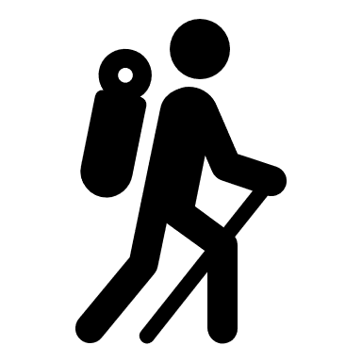 Hiking Gear
- Day Pack
- Headlamp (w/extra batteries)
Optional:
- Trekking Poles
- _____________
Navigation
- Map(w/waterproof case)
- Compass
Optional:
- GPS
- Altimeter
- Guide Book
- Personal locater beacon
- _____________
Tools and Repair
- Knife or multi-tool
- Duct tape
- Gear repair kit
- Bear Spray (if needed)
- ______________

Emergency Items
- First Aid Kit
- Lighter/matches
- Firestarter
- Tinder
- Emergency Blanket/ Emergency Shelter
- Whistle
- Signal Mirror
- Water Purification
- Paracord
- Two itineraries: one left with friend + one in vehicle
- _______________
- _______________
Food and Water
- Water bottle/bladder
- Trail Snacks
- Lunch + extra meal
- Energy boosting snack or drink
- ________________
- ________________

Personal Items
- Identification
- Cash or Credit card
- Cellphone
- ________________
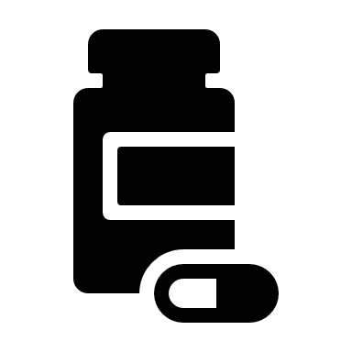Personal Care
- Prescription meds(if needed)
- Hand Sanitizer/Wipes
- Toilet paper
- Trowel
- Sunscreen
- Bug spray
- Pack towel
- Lip balm
- Mole skin
- Bag for trash
- ______________
- ______________
Extras
- Camera
- Binoculars
- Pen and Journal
- _____________

Clothing and Footwear

*Try to avoid cotton clothing, it is not breathable and does not dry quickly

- Moisture-wicking breathable T-shirt
- Moisture-wicking breathable underwear
- Hiking quick-drying pant or shorts
- Wool or synthetic socks (plus extra pair)
- Moisture-wicking breathable long sleeve T-shirt
- Lightweight mid layer for warmth
- Waterproof Jacket
- Waterproof Pants
- Boots or shoes suited to terrain
- Hat
- Buff/Bandana
- Gaiters
- Light weight gloves
- Sunglasses
- Extra Clothes (in case you get wet or conditions change)
- Drybag to keep extra clothes in
- ______________________________
- ______________________________
- ______________________________

Being prepared is essential to back country travel, not only for your safety but piece of mind. Having the proper gear will allow you to travel safer and more comfortably.

Cold Weather Additions

*Try to avoid cotton clothing, it is not breathable and does not dry quickly

- Base layers (wool/synthetic)
- Insulated Jacket (down/synthetic)
- Gloves/Mittens
- Warm Hat
- Facemask
- Insulated Waterproof Boots
- Microspikes/Crampons
- Snowshoes/Skis
- _____________________________
- _____________________________
- _____________________________

